**Project 5: Run a Django Project, Prepare Output Datasheet and forward it to the Requested Email**

**Problem Statement:** To create a Bot to run a Django Project available in the system and Login to the Website with Given Credentials in the Django Project.

Extract an output Datasheet for the given Set of Inputs to predict through a ML model and send it to the requested EMAIL.

**Solution Definition:**

We will create one Master Bot and six Sub Bots.

1. **loginCheck_Subbot:**

* Aim: Checks whether the System has Logged in Already.
* Input: Receives a Window Variable has input to locate the website
* Output: Returns a Boolean Variable (Logged In – True, Else – False)

1. **loginToProject_Subbot:**

* Aim: Logs in to the Website with provided Credentials.
* Input: Receives a Window Variable has input to locate the website.
* Output: No output.

1. **insurancePredictor_Subbot:**

* Aim: Predict the Insurance using the provided input variables through the model available in the Website.
* Input: Receives AGE, BMI, GENDER, NOC, REGION, SMOKER has inputs.
* Output: The Predicted value is Output.

1. **extractInputValues_Subbot:**

* Aim: To extract input values from an excel sheet and set it as inputs to the ‘InsurancePredictor_Subbot’ and receive the Predicted value as Output and Store all the data in a new Excel Workbook. Run sendMail_Subbot to send mail attaching the Excel Workbook created.
* Input: No input.
* Output: No output.

1. **sendMail_Subbot:**

* Aim: To receive the System Path for an Excel File and a mail address as inputs and send a mail to the given input mail address.
* Input: System Path and EMAIL address as String Variables.
* Output: No output.

1. **goToMLProject_Subbot:**

* Aim: To re-direct from Main dashboard of the website to the ML Predictor Model. From there Run extractInputValues_Subbot.
* Input: No input.
* Output: No output.

1. **runMyDjangoProject:**

* Aim: To Run the Requested Task in Problem Statement and utilizing the Sub-bots.
* Procedure Will be Explained in the Next Page.

**Procedure to Create the Bot:**

**loginCheck_Subbot:**

1. Login in to your Control Room and Create a bot.

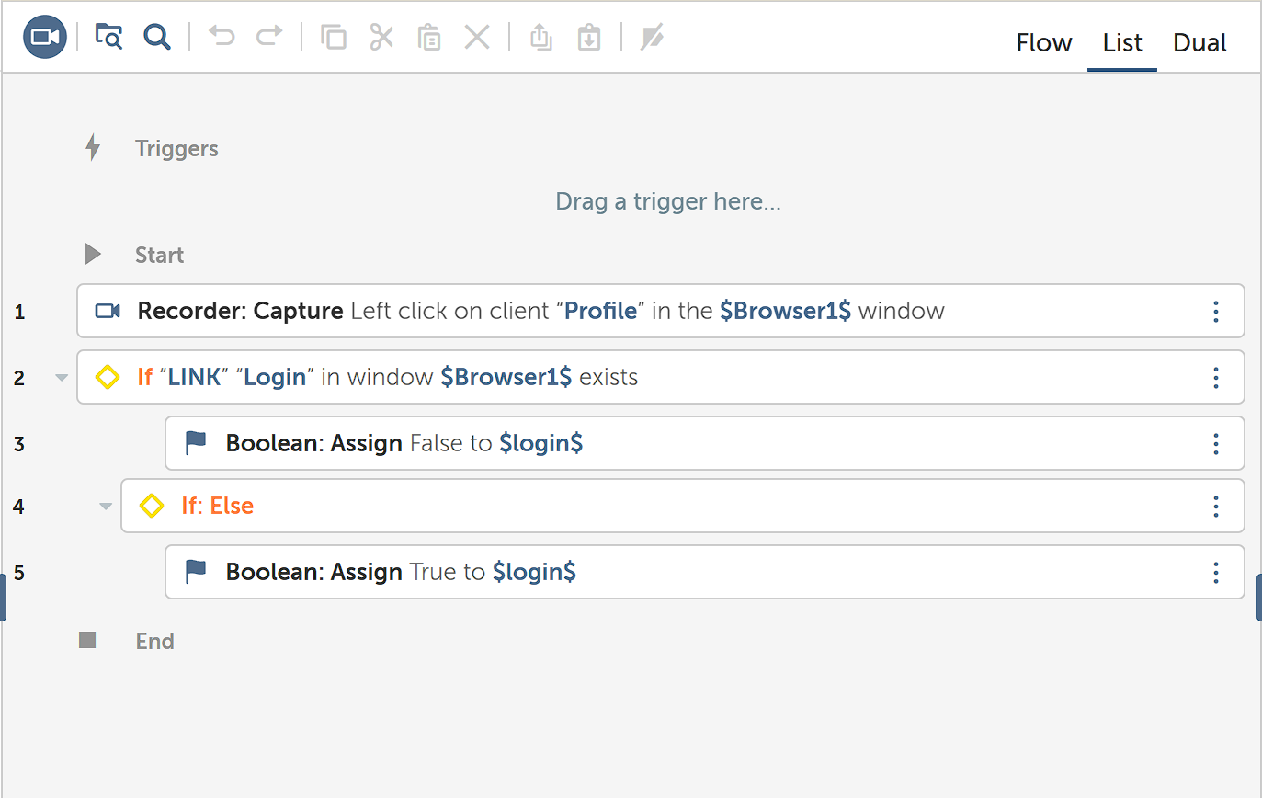

1. Now in the action Panel, this is how you would build the structure

**loginToProject_Subbot:**

1. Create another new bot.

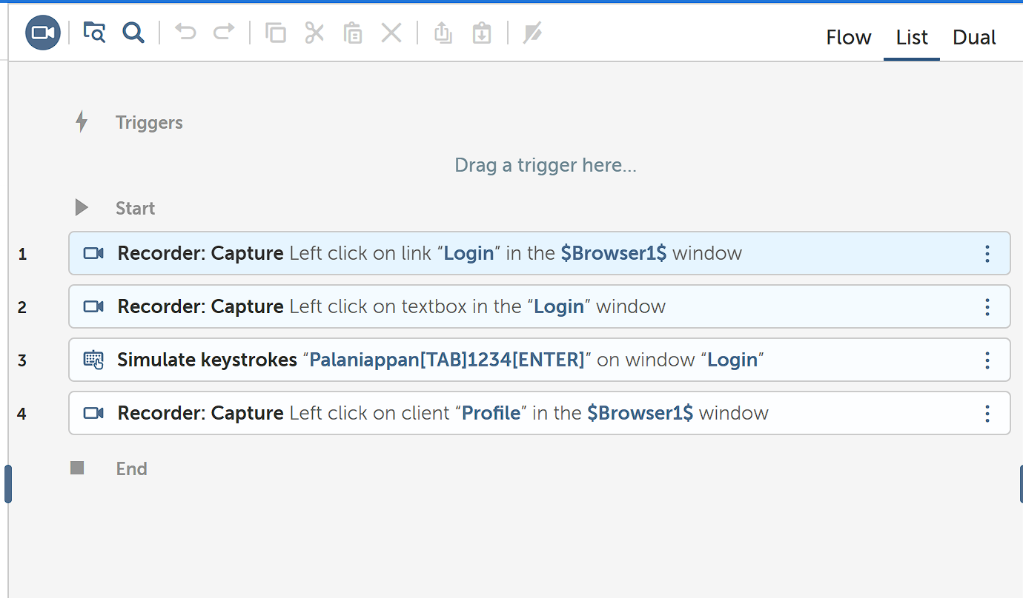

1. Now in the action panel, this how you would build the structure.

**insurancePredictor_Subbot:**

1. Create a new bot.

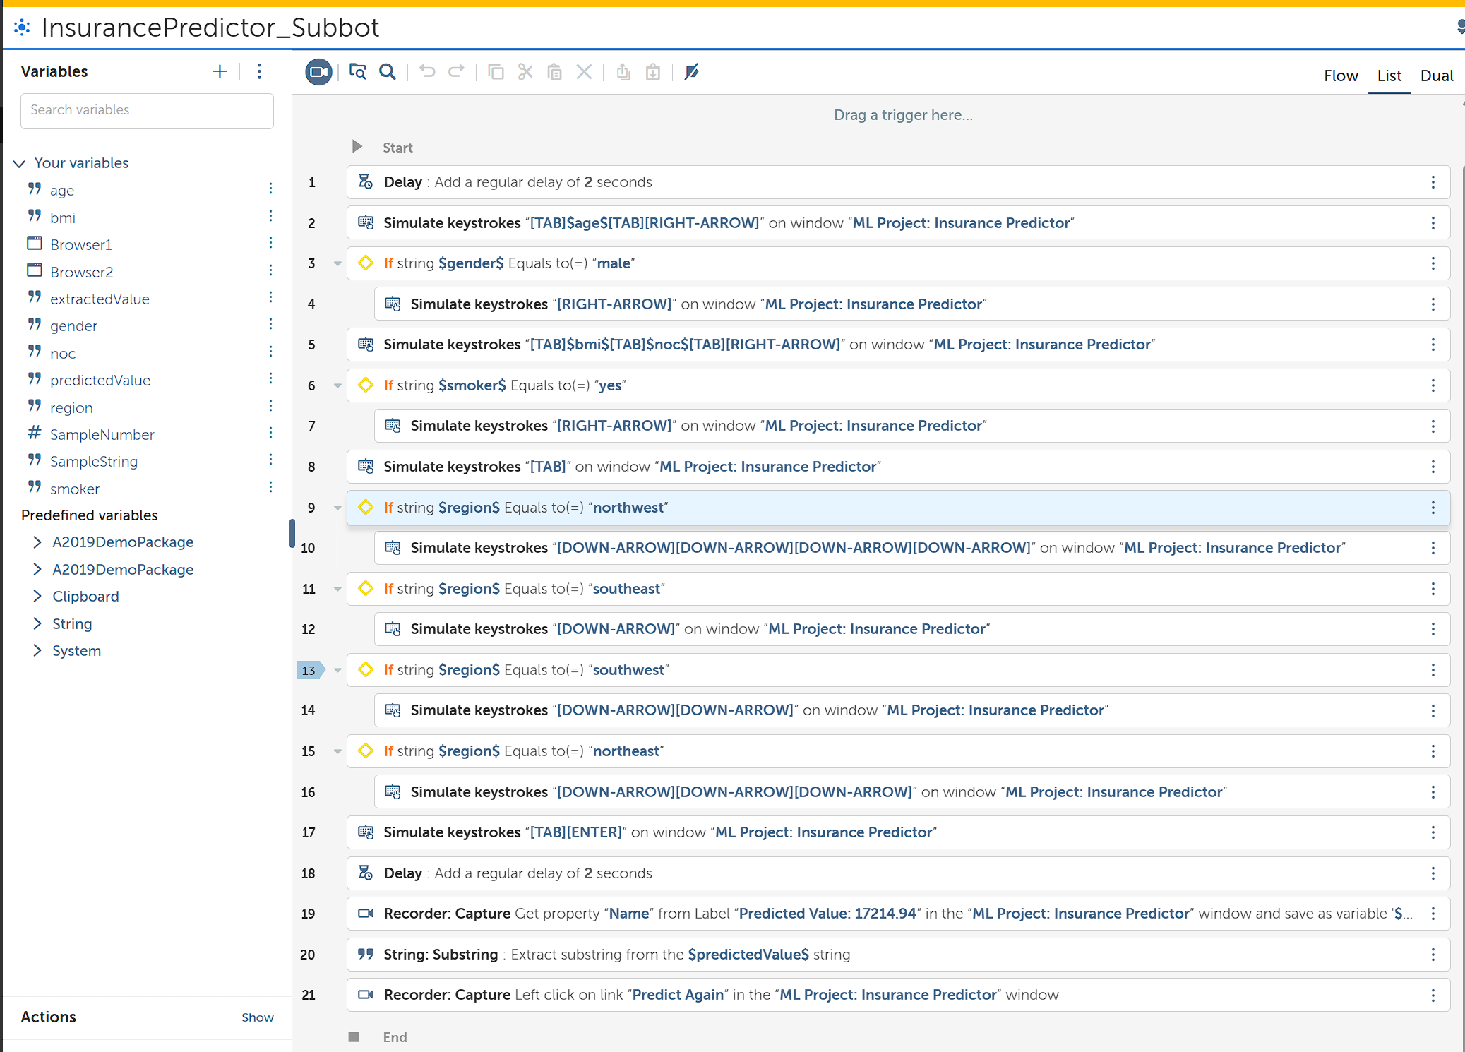

1. Now in the action panel, this is how you would build the structure to handle without using Capture for consistency of the Form.

**extractInputValues_Subbot:**

1. Create a New Bot.

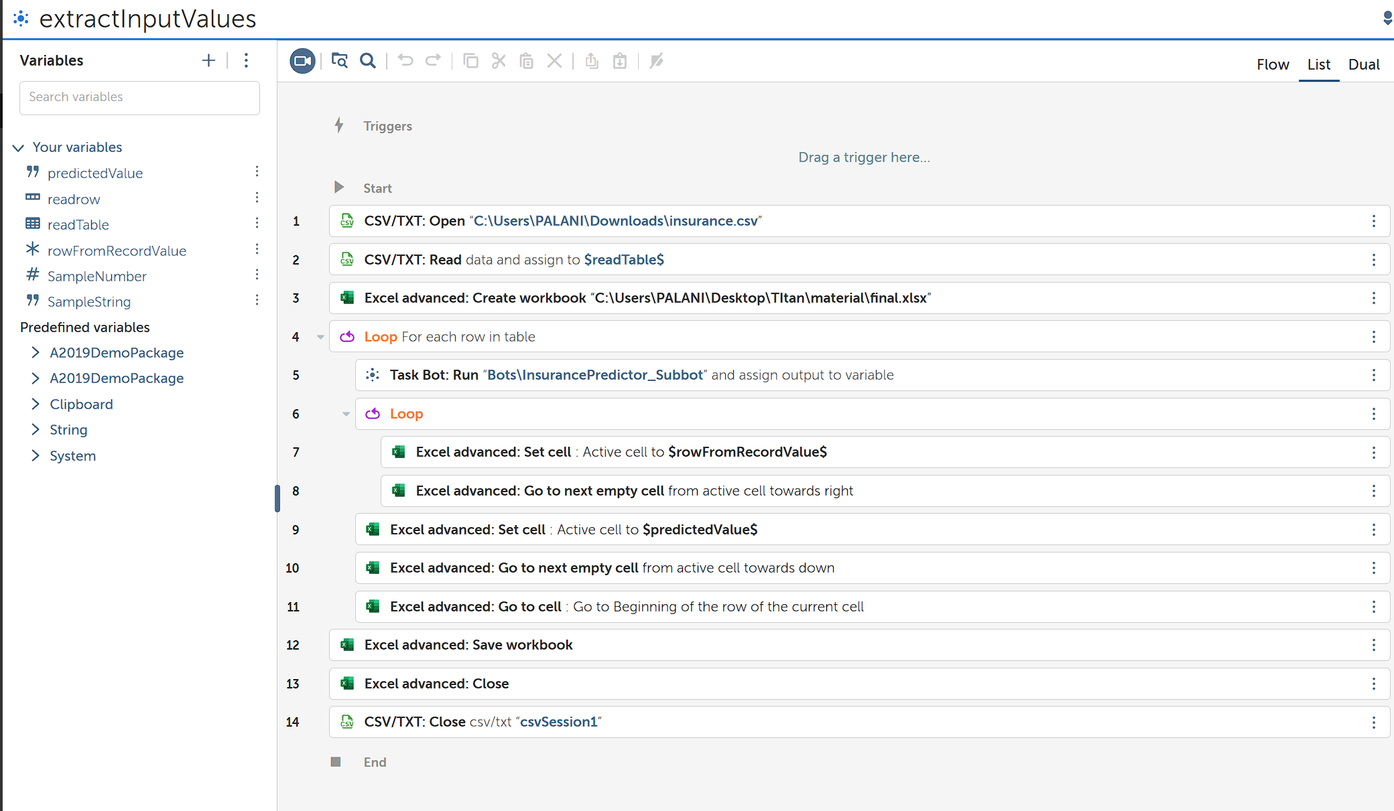

1. Now in the action panel, this is how you would build the structure.

**sendMail_Subbot:**

1. Create a new bot to Send Mail after successfully extracting output values.

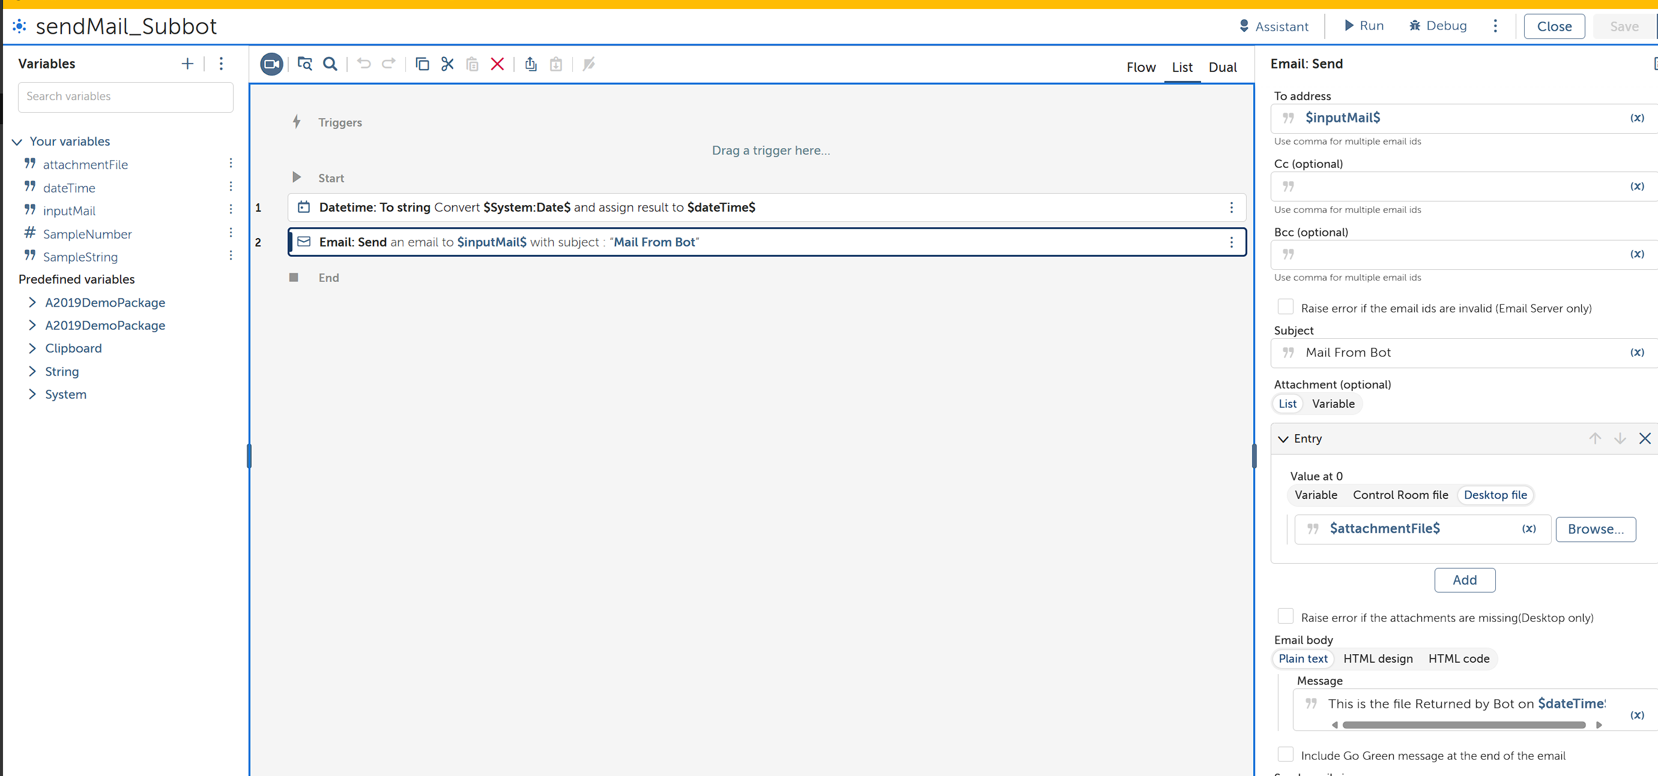

1. In the action panel, this is how you would build the structure.

**goToMLProject_Subbot:**

1. Create a new Bot.

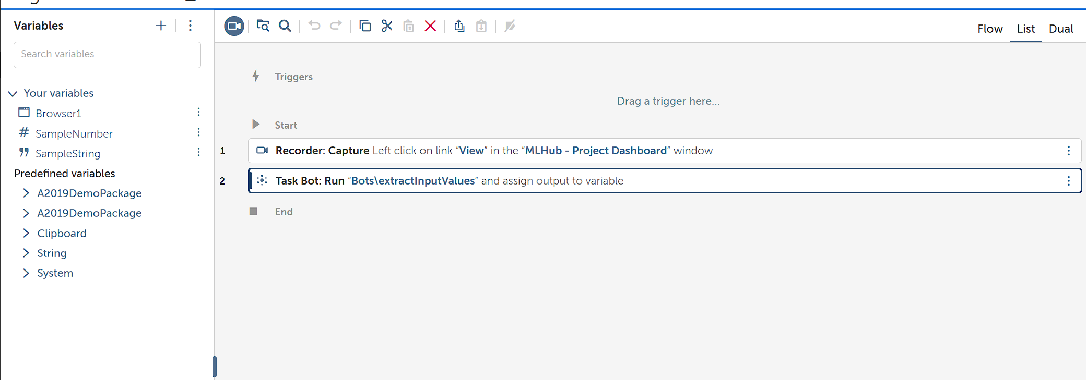

1. In the action panel, this is how you would build the structure.

**runMyDjangoProject:**

1. Create another new bot, you will be re-directed to Action panel.

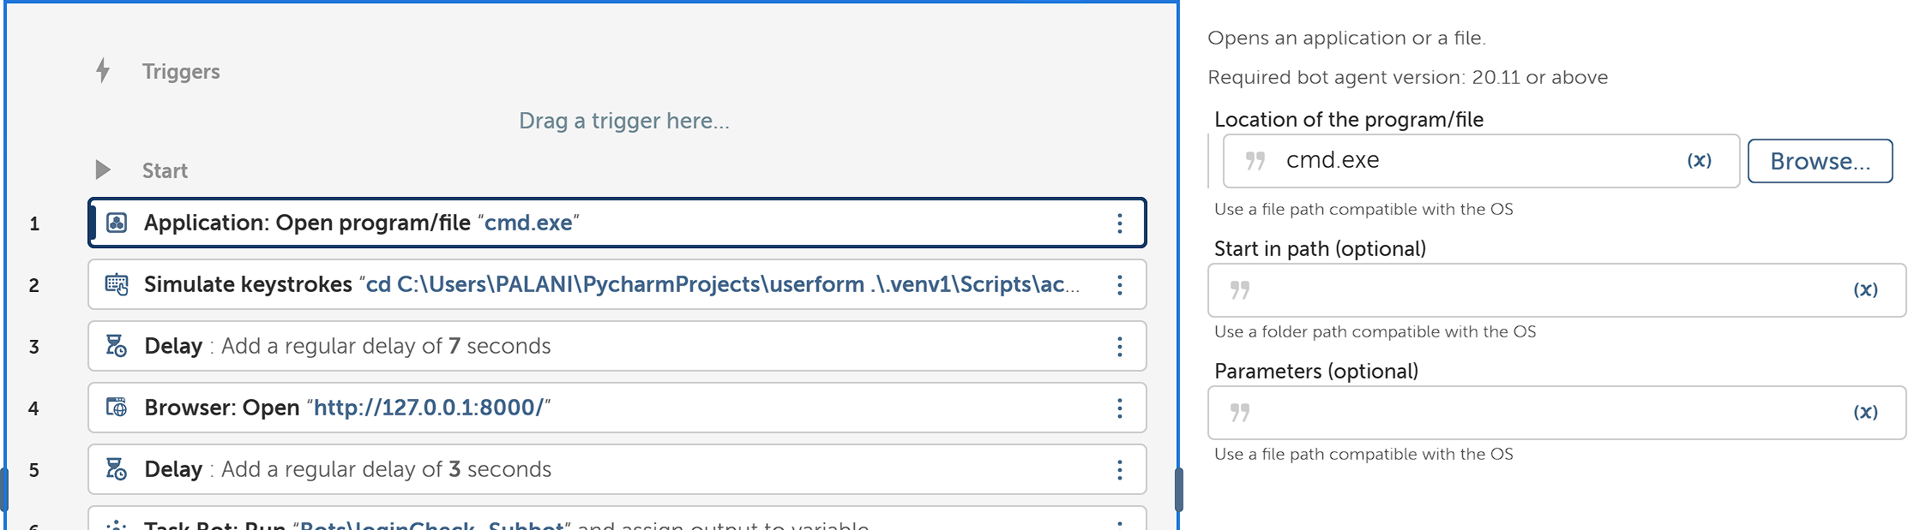

1. Open the Command Prompt.

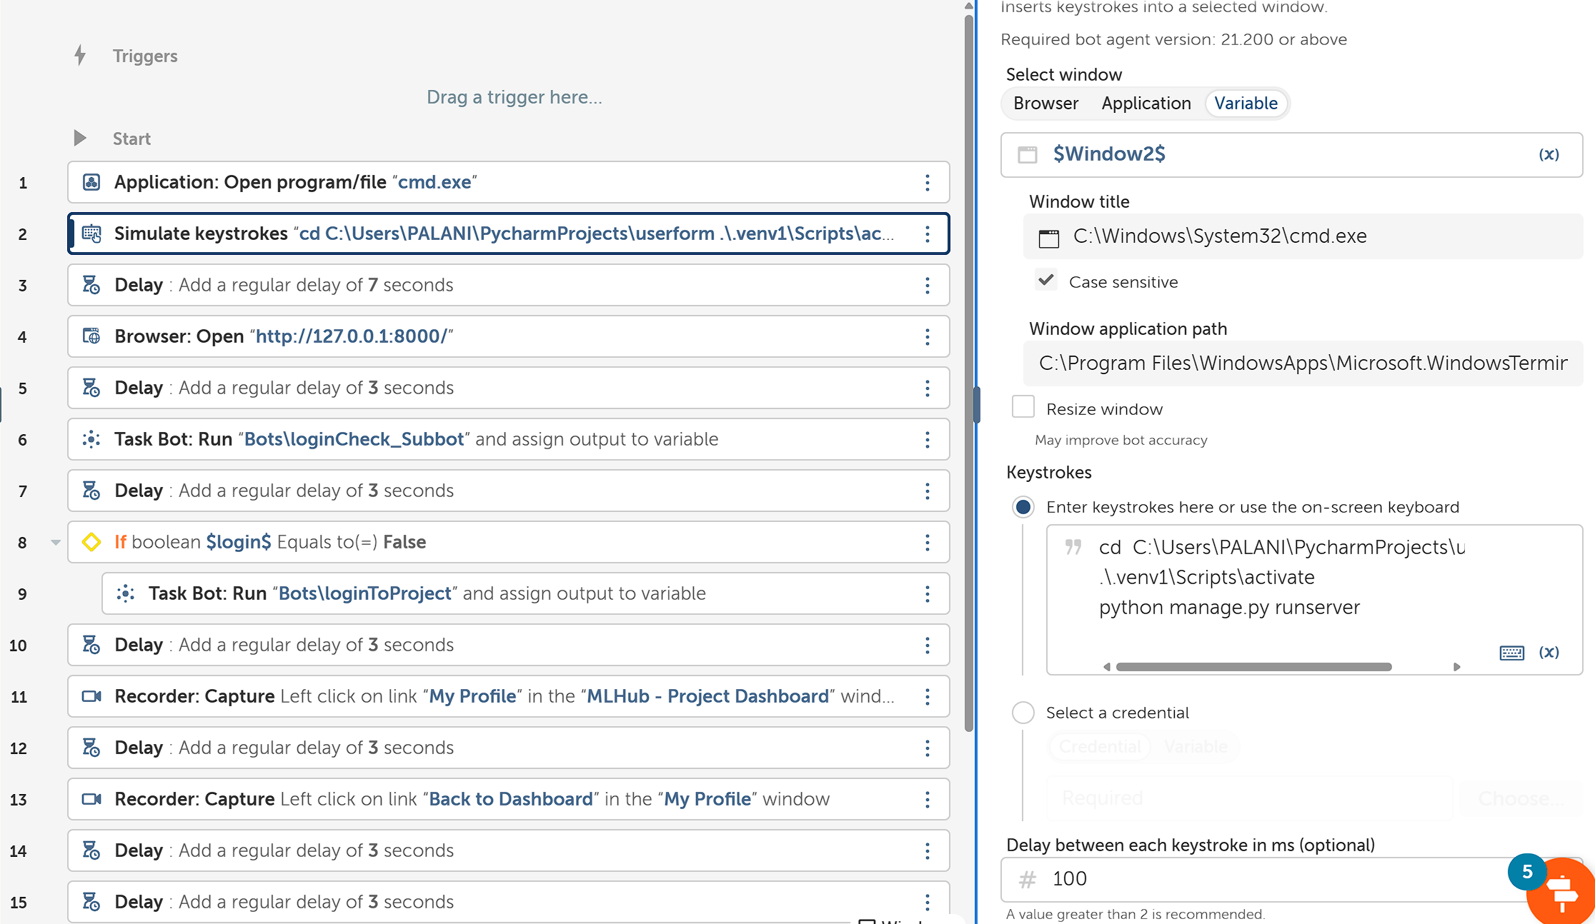

1. **Simulate Keystrokes** to Direct to Django Project Folder and Run the Project.
2. Add **delay** to Wait for the Project to Create a Local Environment.

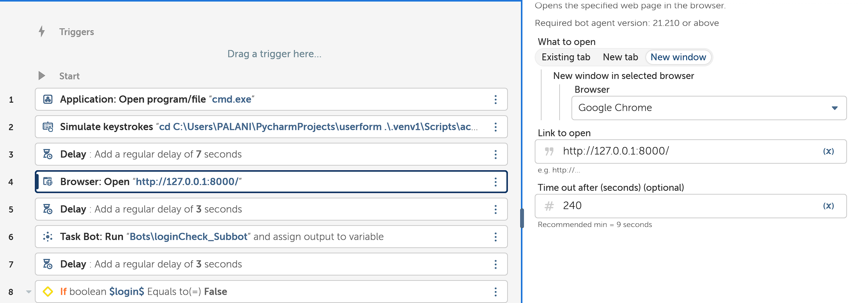

1. **Open** the Local Host in

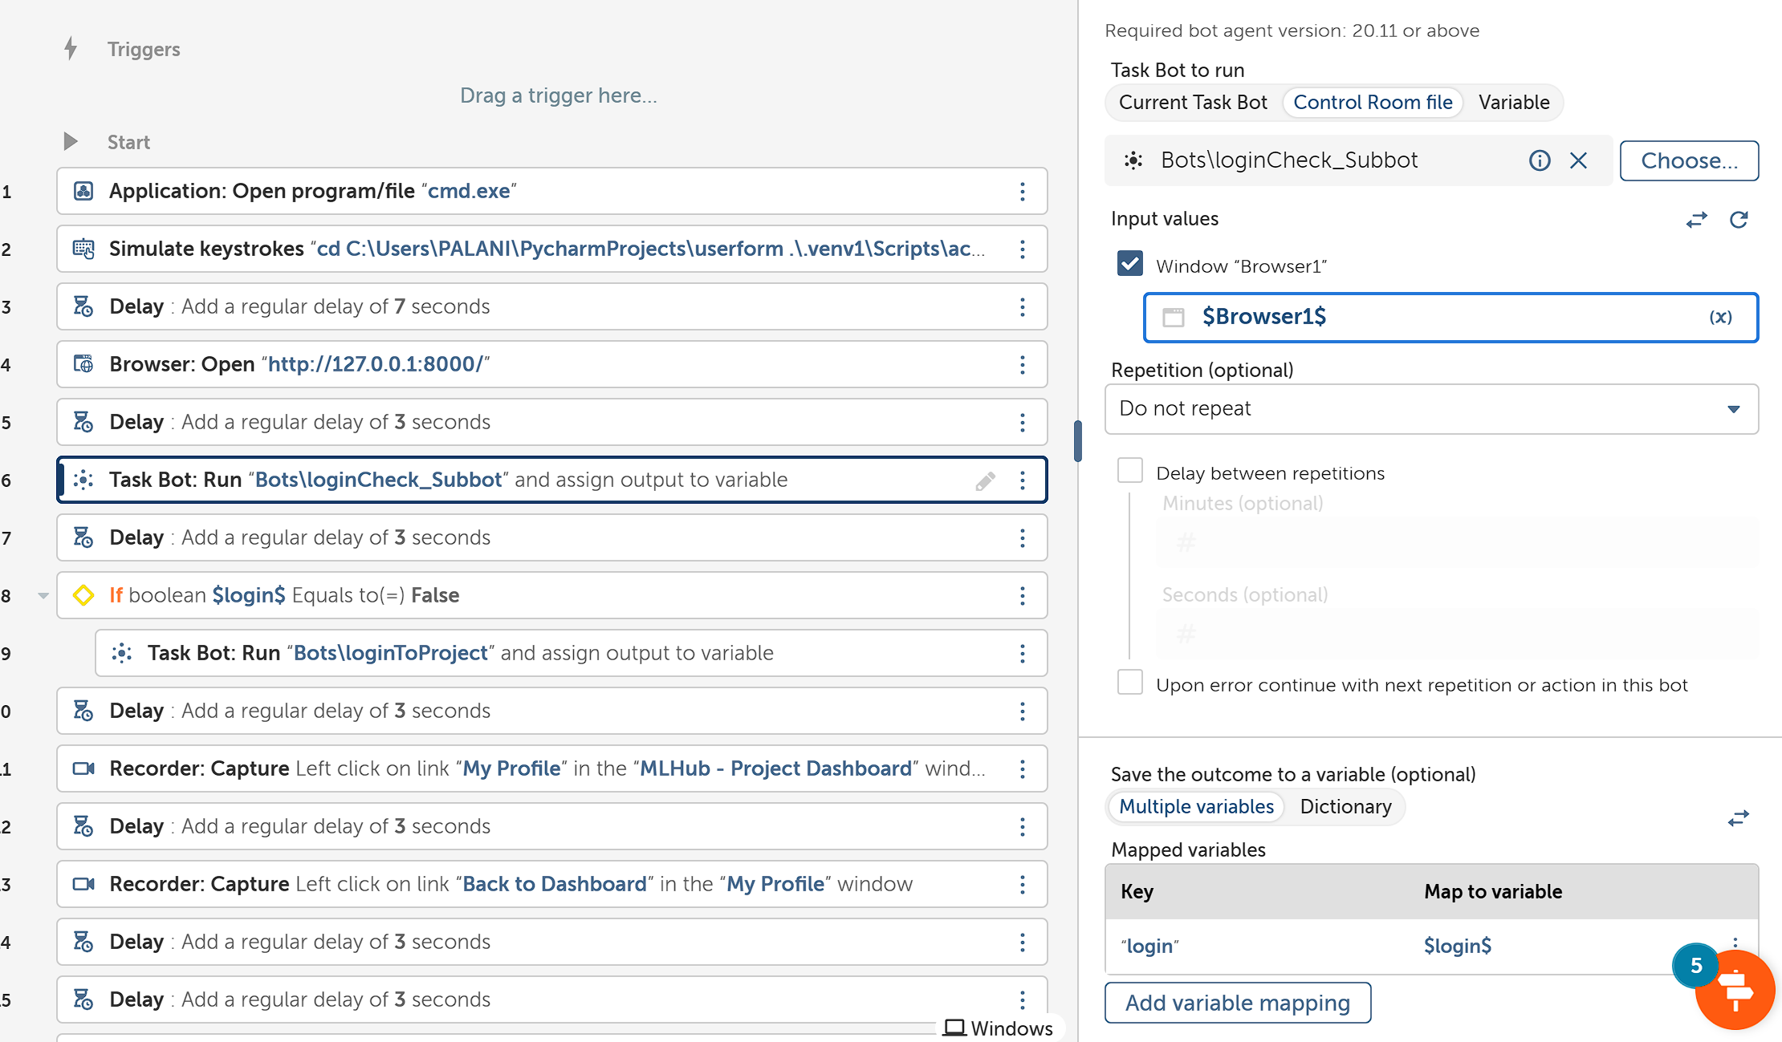

1. **Run** the **loginCheck_Subbot** to Check whether the System has logged in Already. **Provide Browser1** has input and **receive ‘login’** a Boolean value has output.

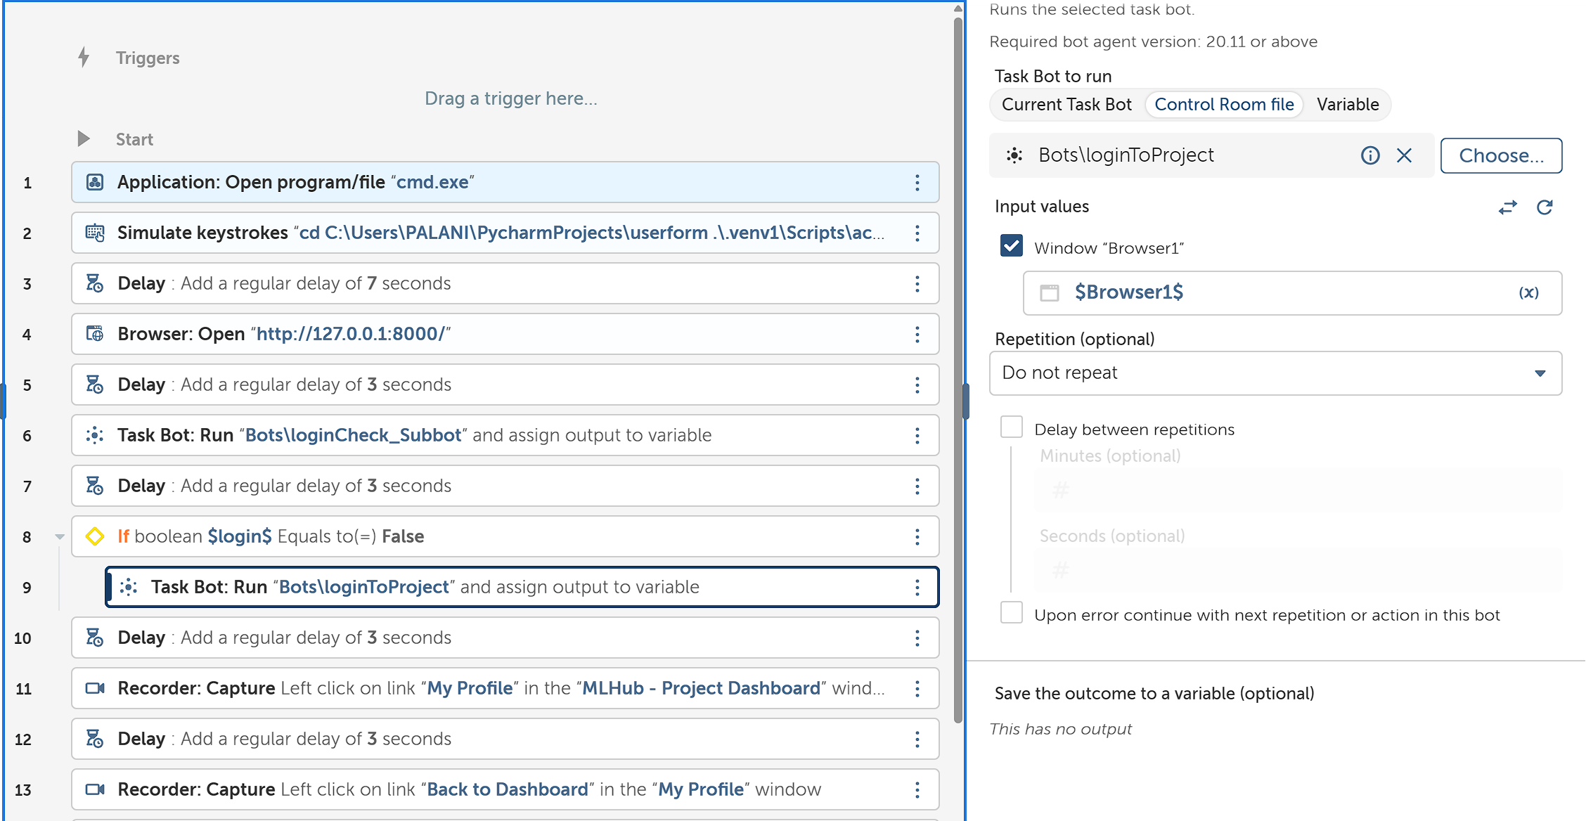

1. Check if **login equals to False**, if so **Run loginToProject Bot**. **Provide ‘Browser1’** has input

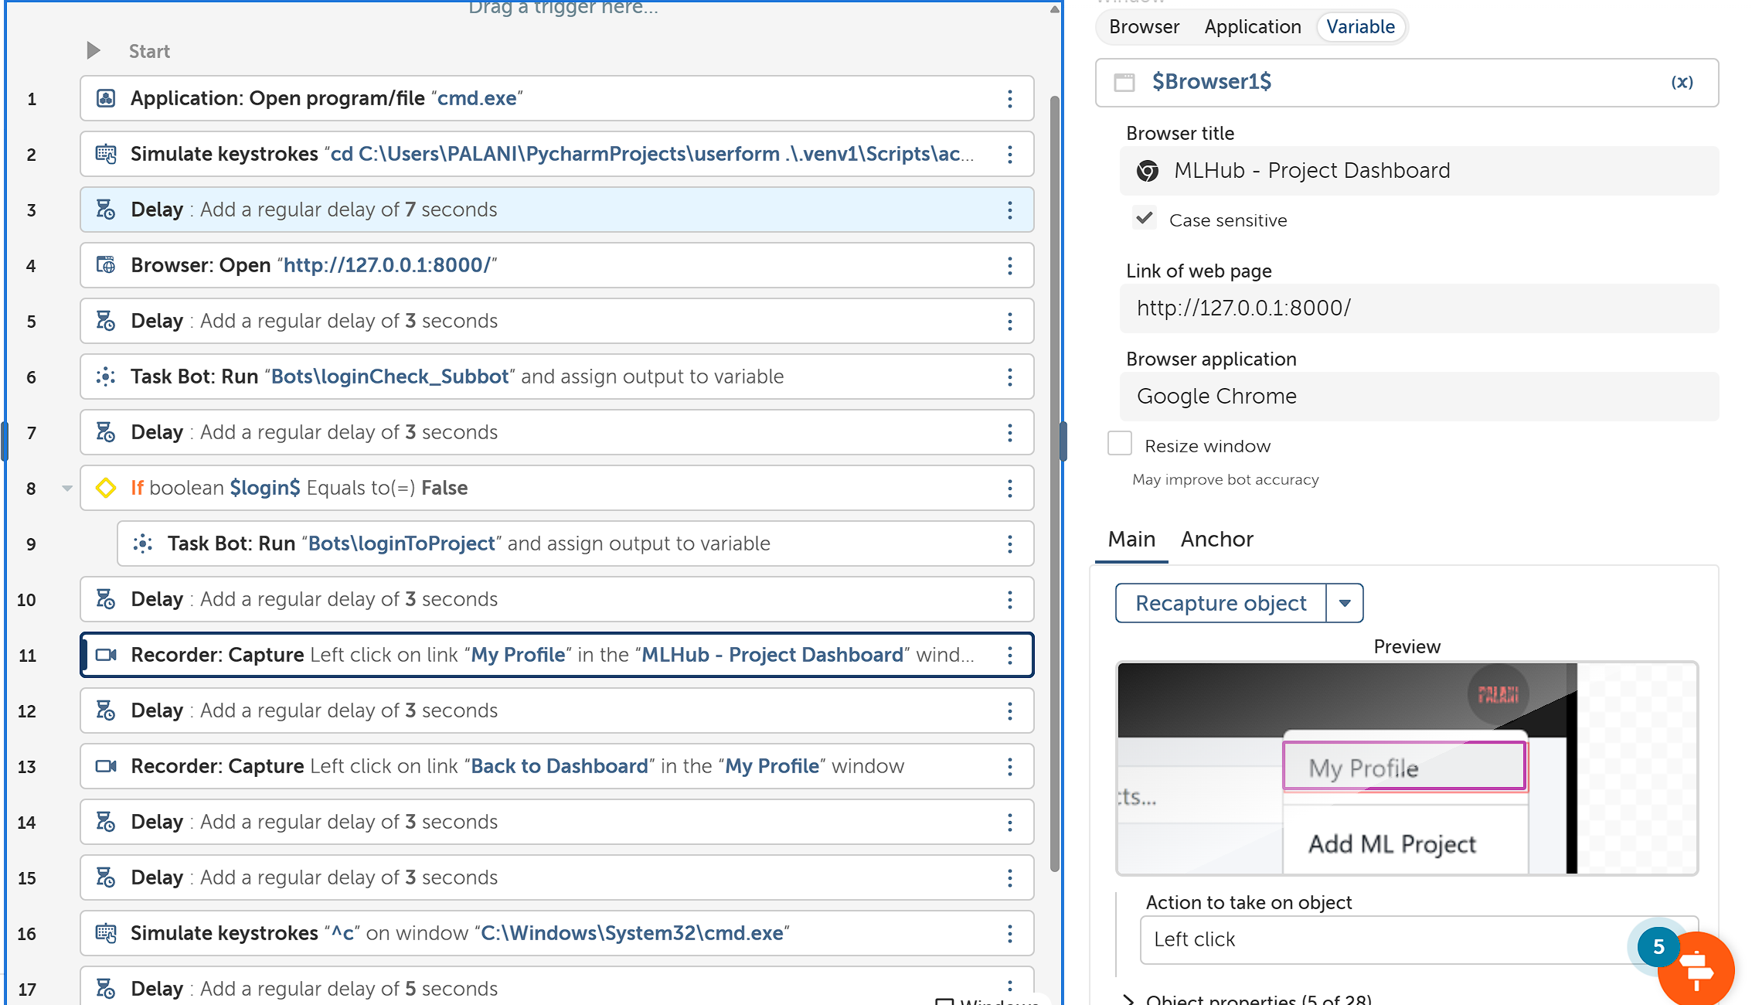

1. Click **My Profile** Using **Capture** Action, you will be re-directed to your Profile Information Page.

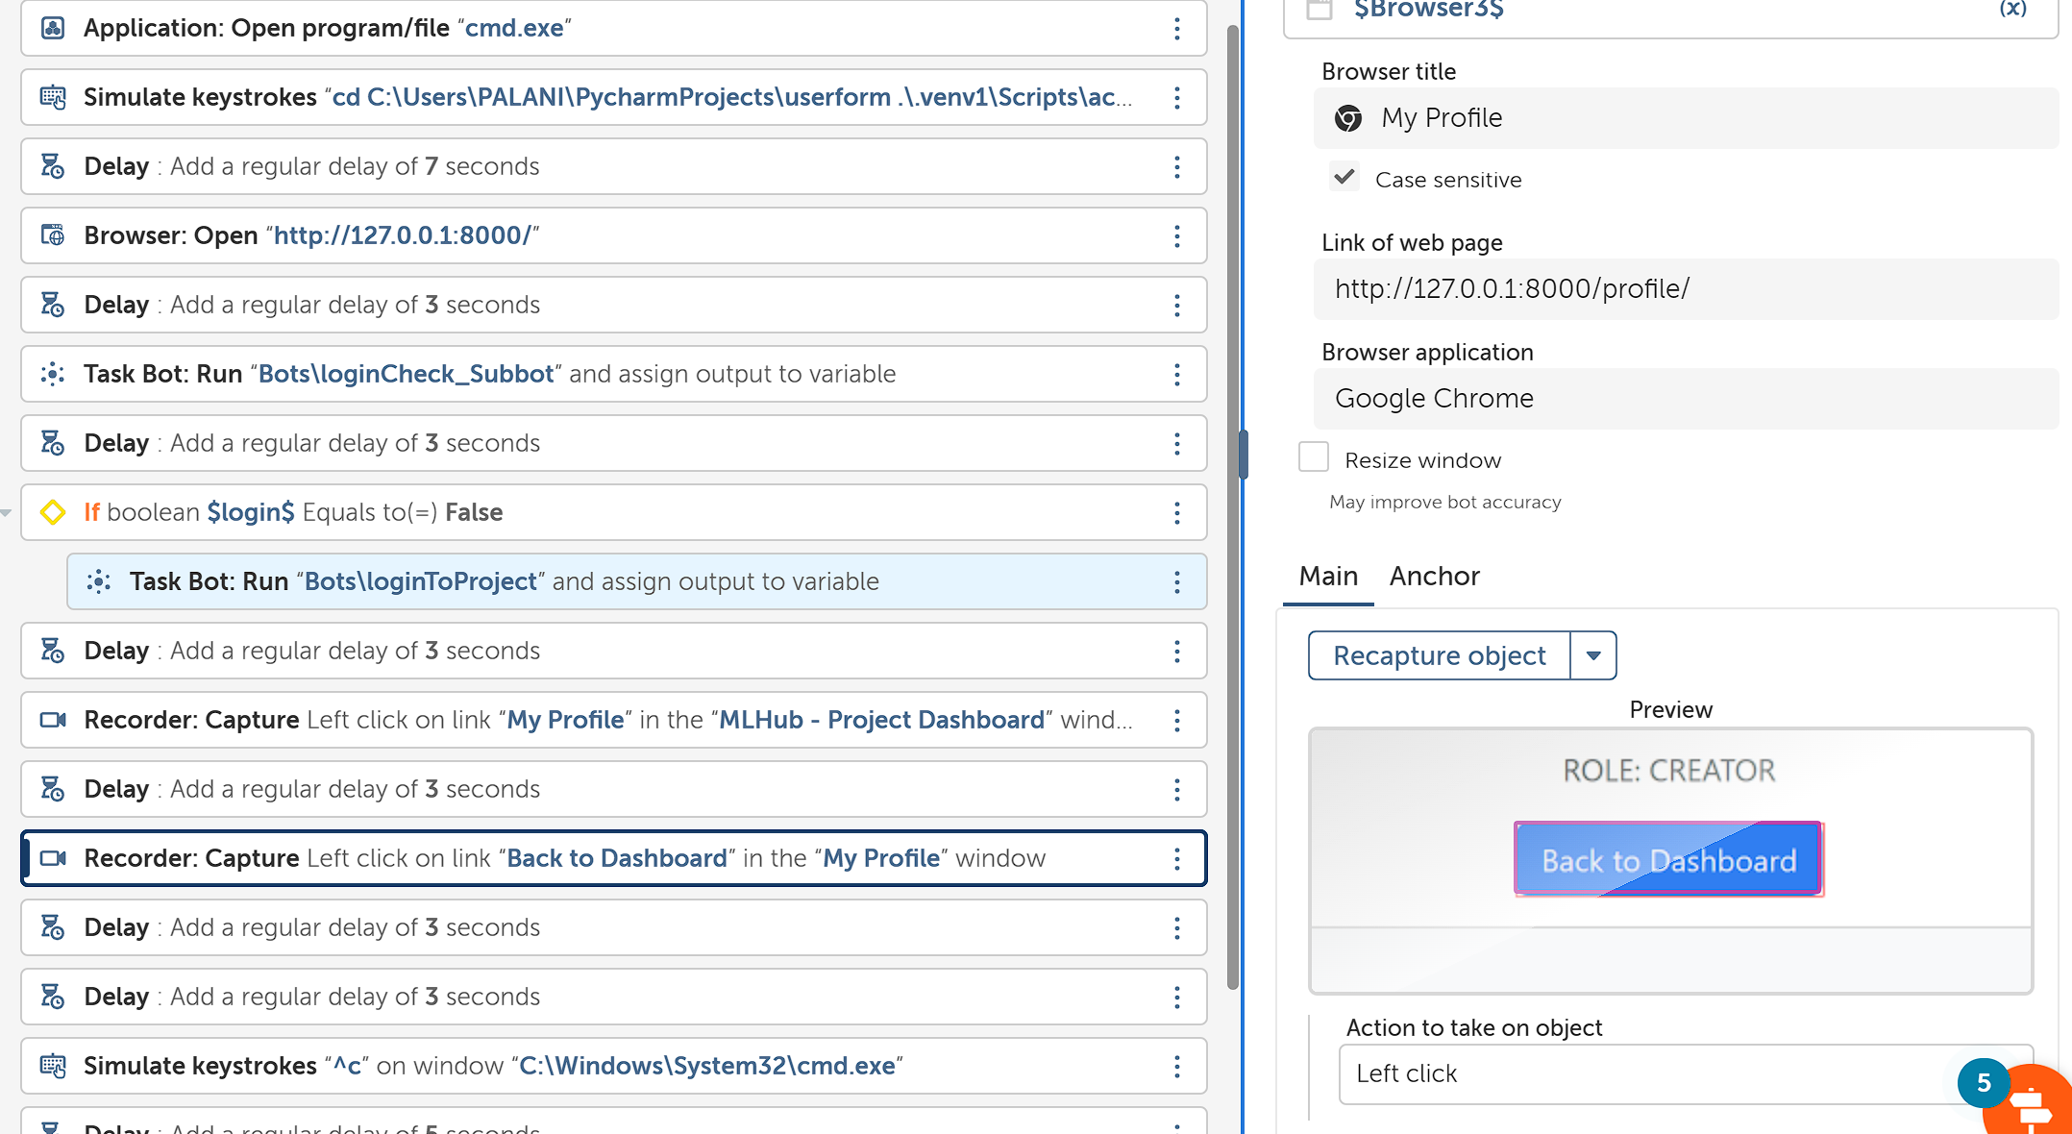

1. Click **Back to Dashboard** using **Capture** Action, to be re-directed back to Main Dashboard.

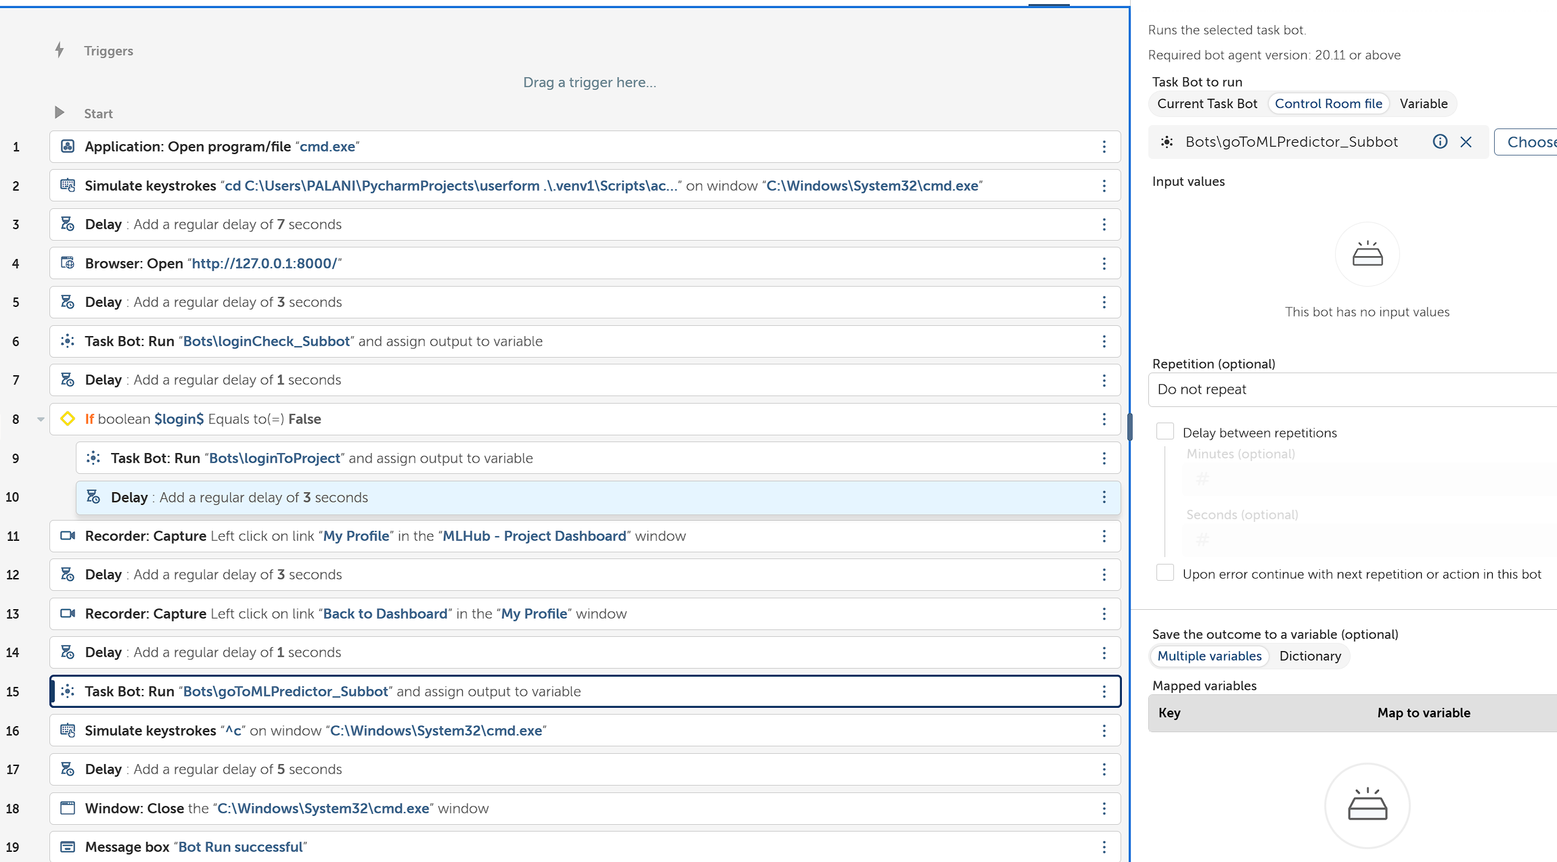

1. Direct to the ML model’s interface, Using goToMLProject_Subbot.

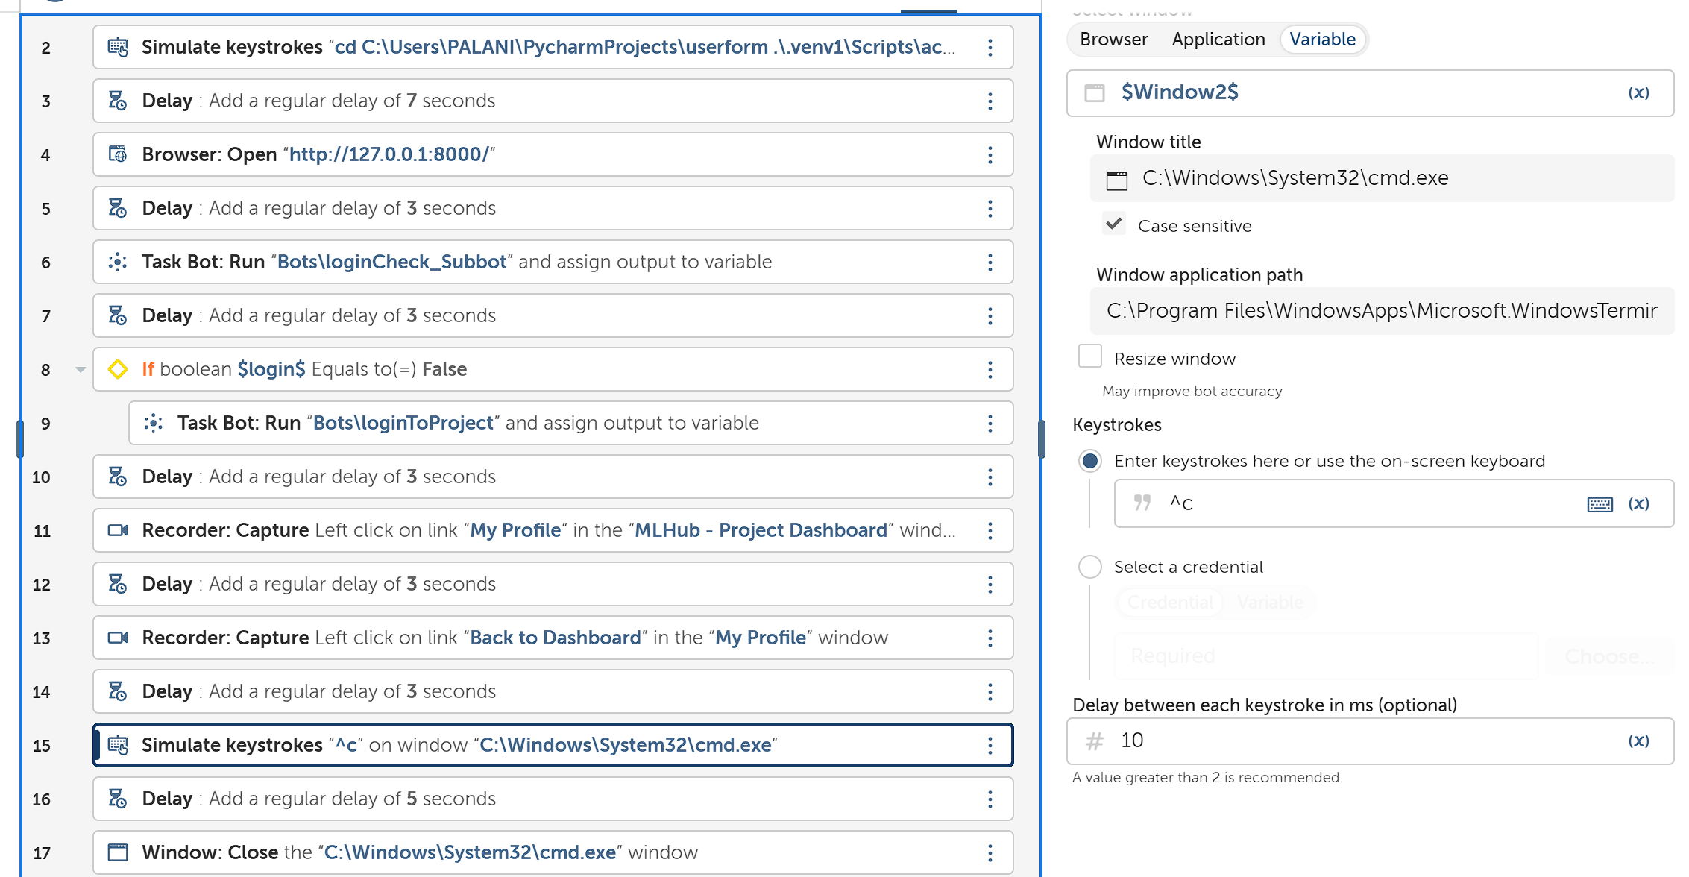

1. **Simulate Keystroke CTRL+C** to Stop the Django Project in Command Prompt.

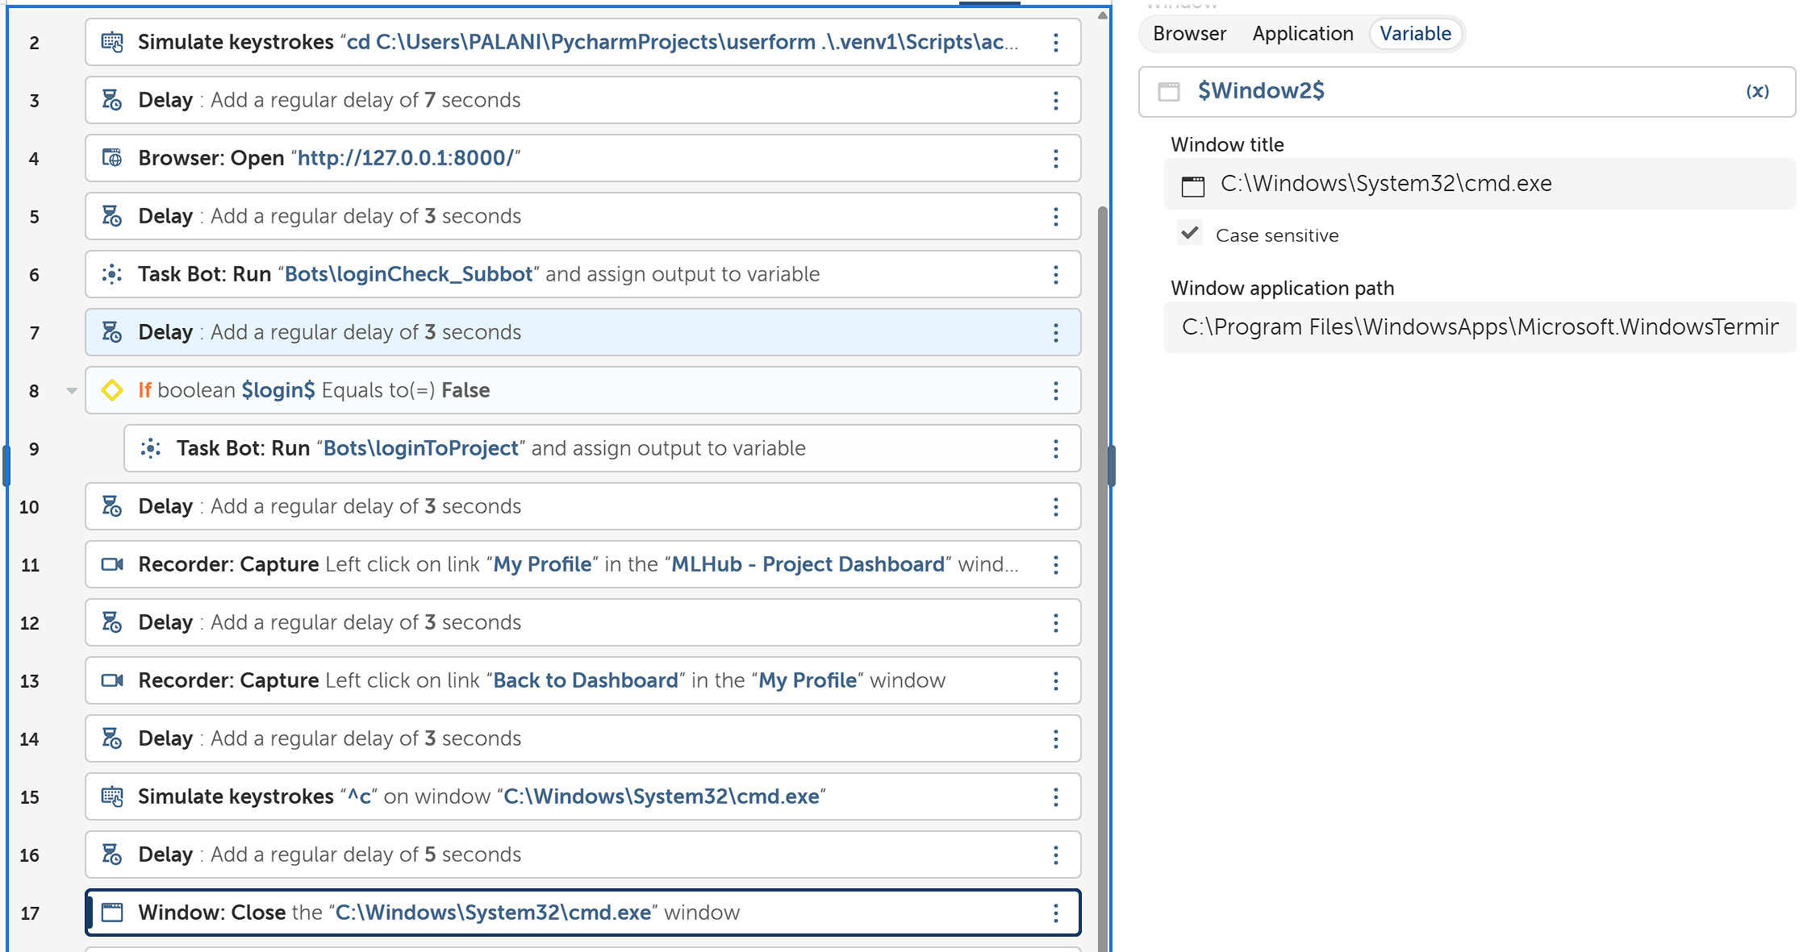

1. **Close** the Command Prompt.

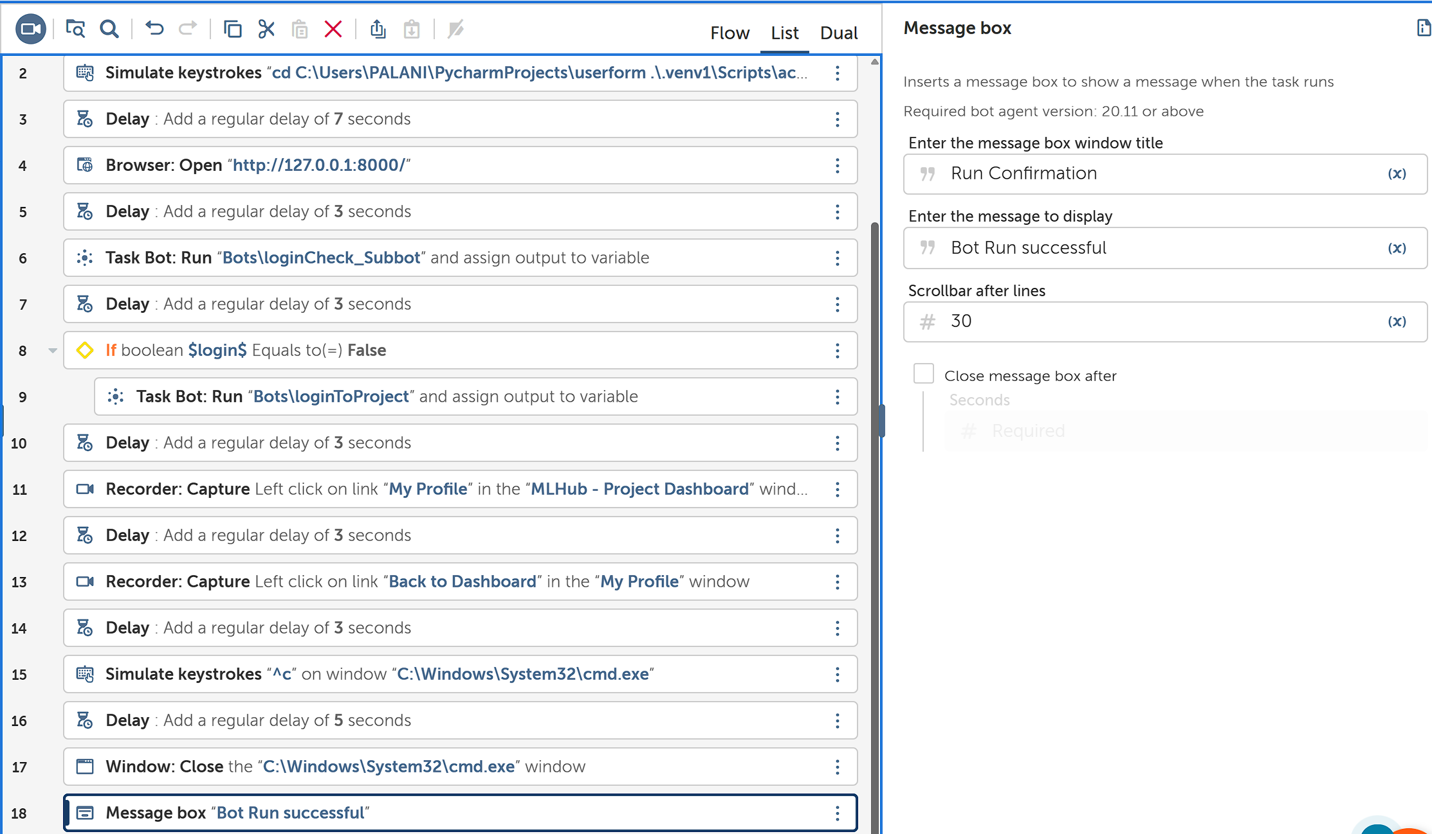

1. Display a **Confirmation message** using **Message Box**.

By these Procedure, we would be able to create Our Successful Bot to run the task according to the Problem Statement.

**Output Of Running the Task Bot:**

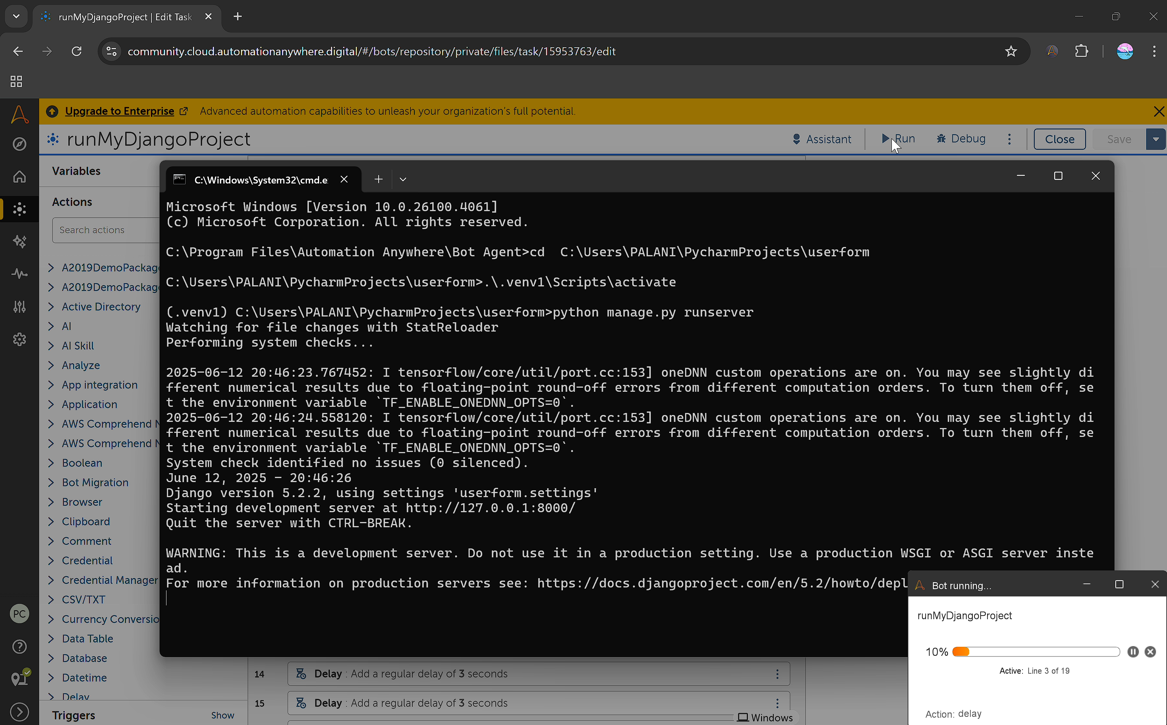

1. Open Command Prompt and Run the Django Project.

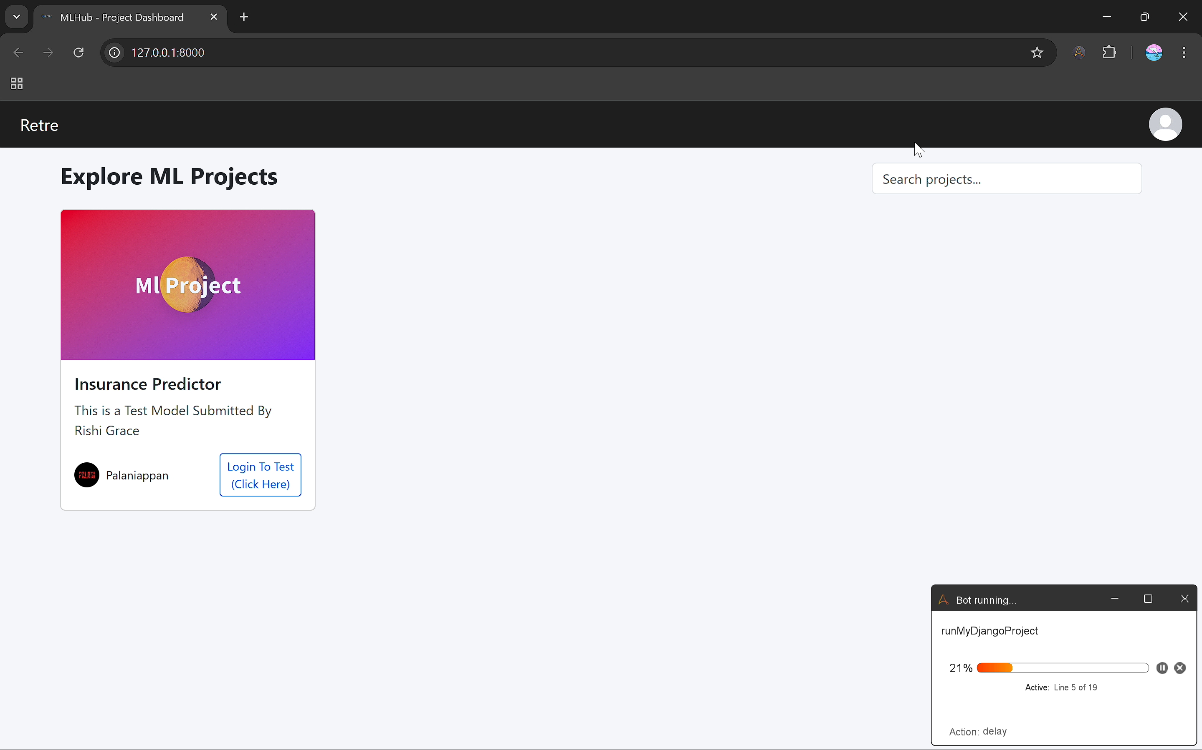

1. Open the Website Using the Local Host.

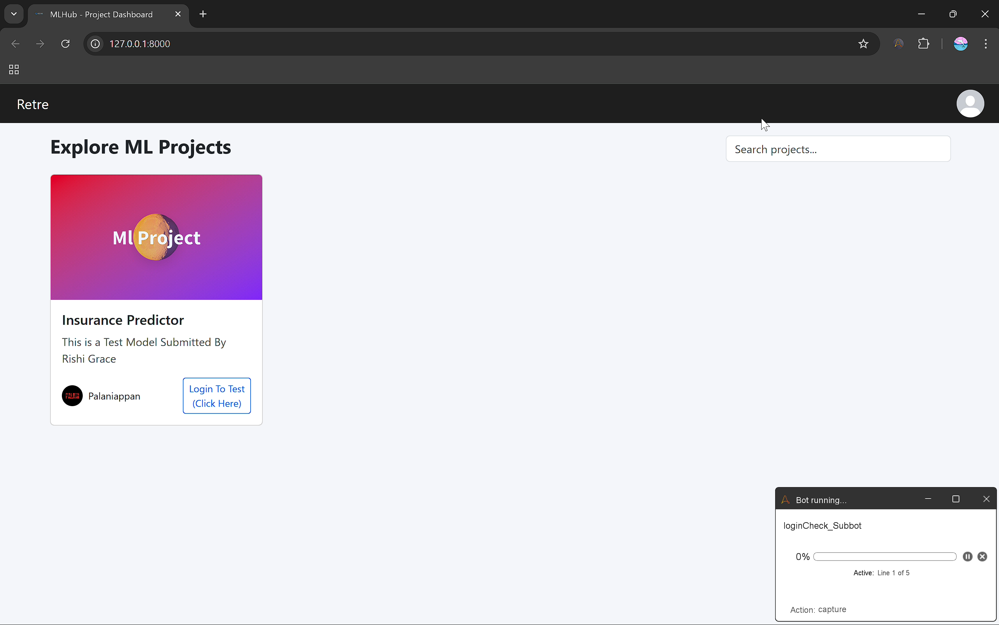

1. Checking whether the System has logged in.

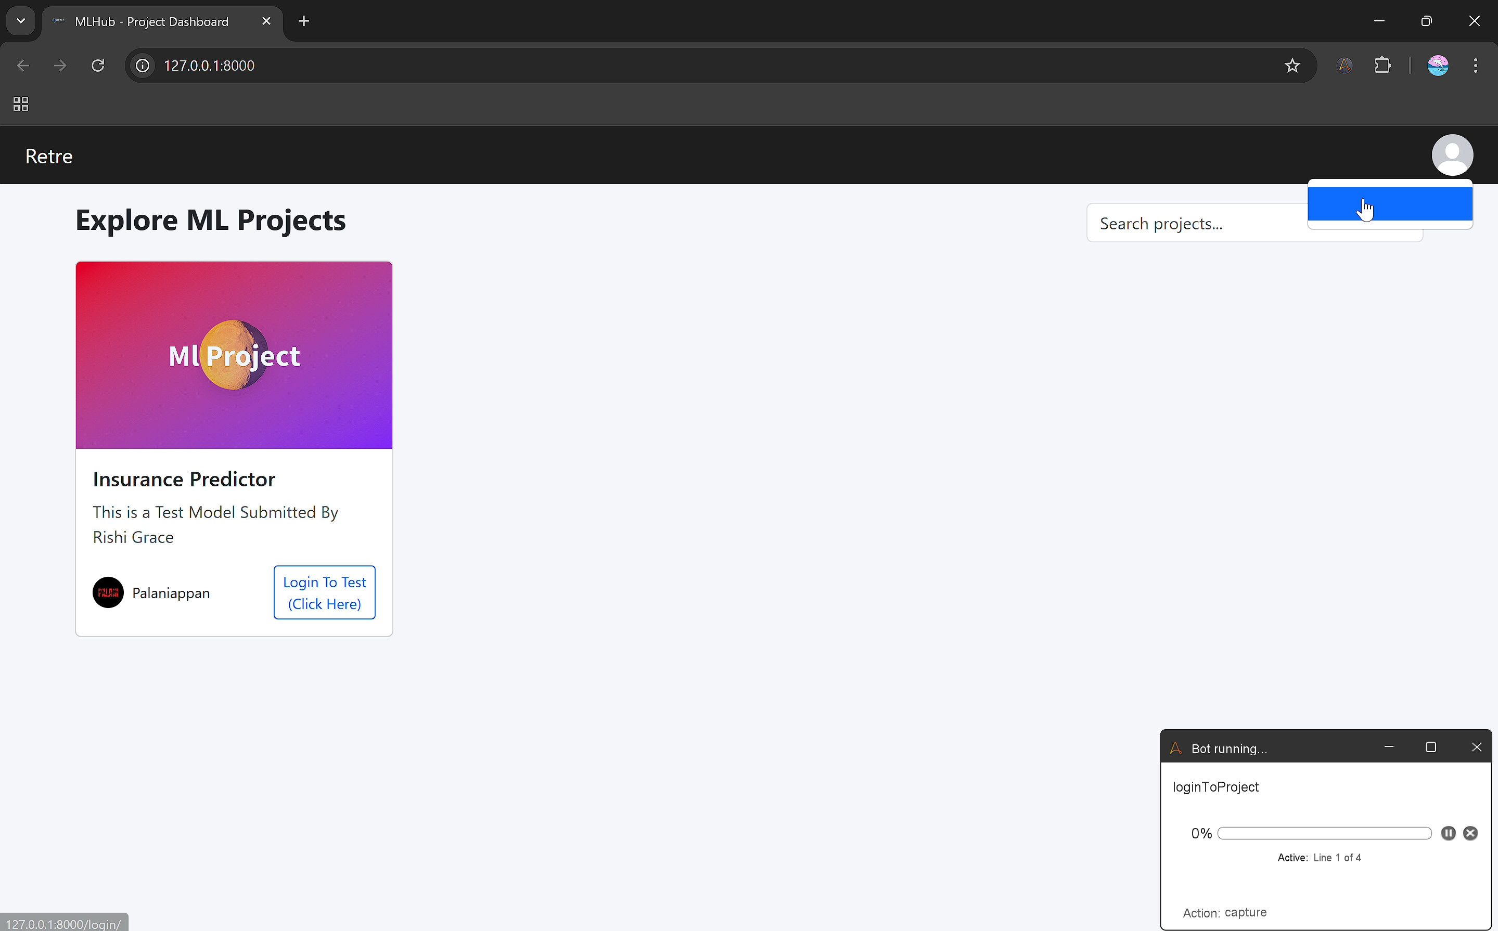

1. Click the Profile and Login.

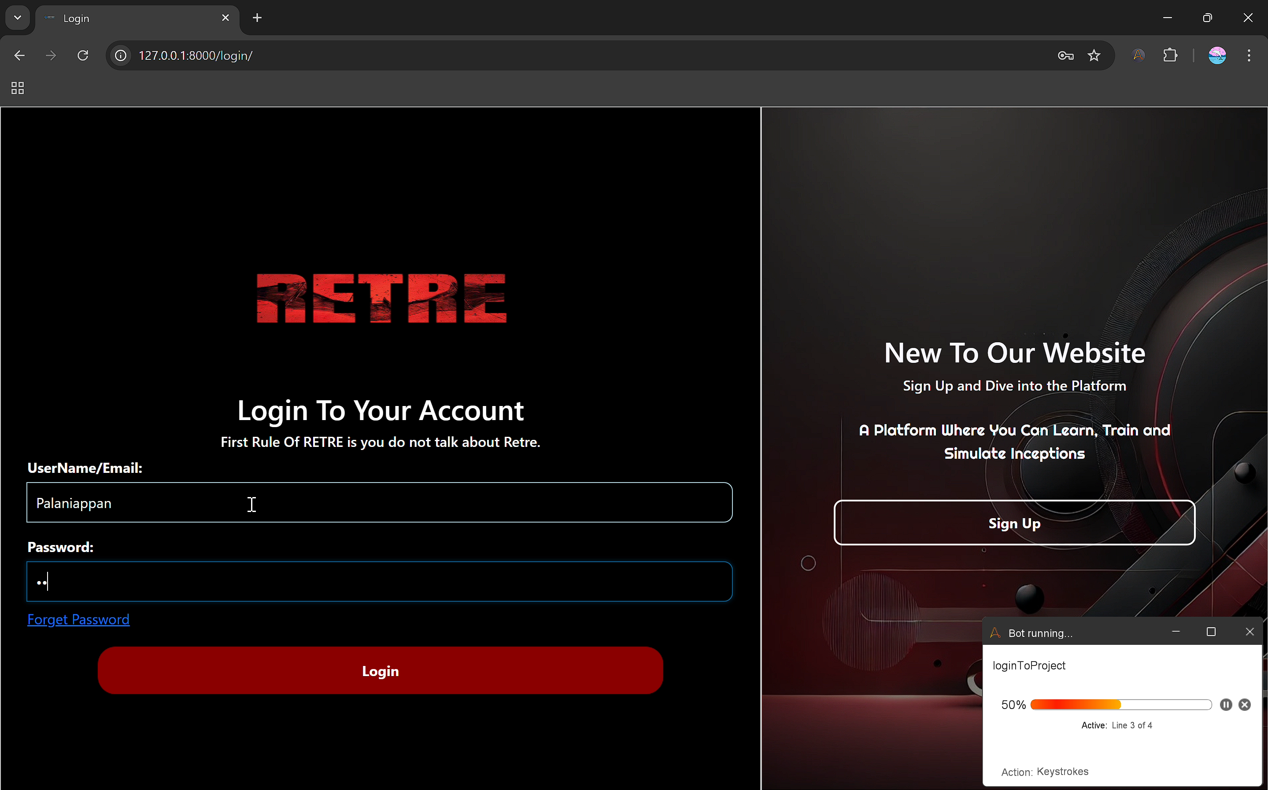

1. Enter the Provided Credentials to Login.

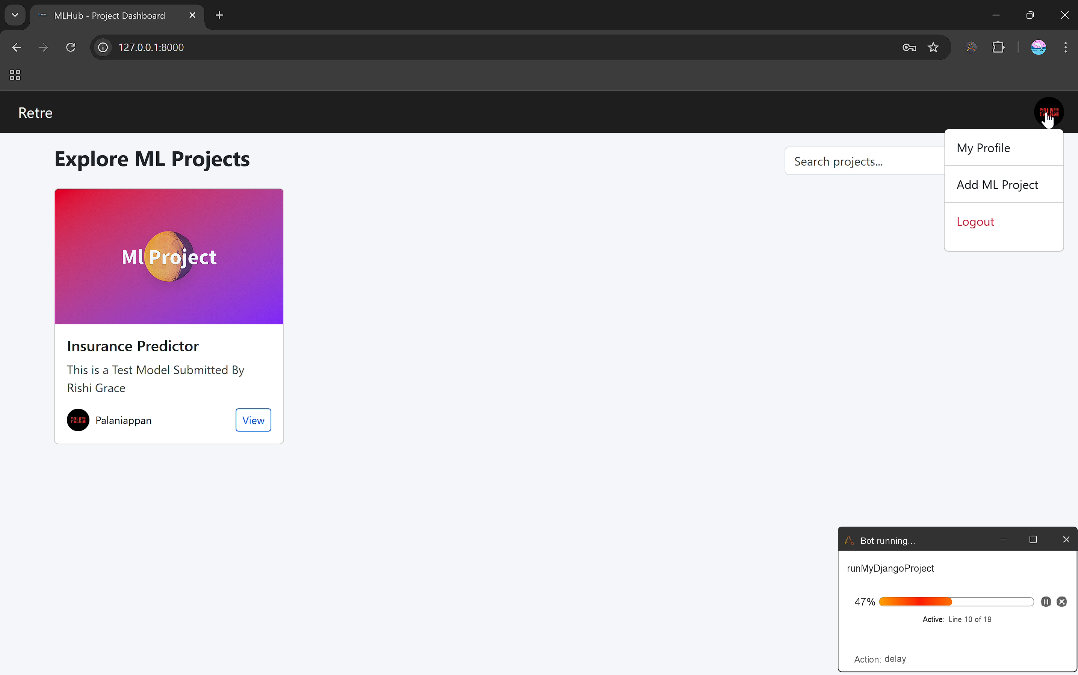

1. Once Re-directed to Main Dashboard, Click Profile and direct to My Profile to view the Profile Details.

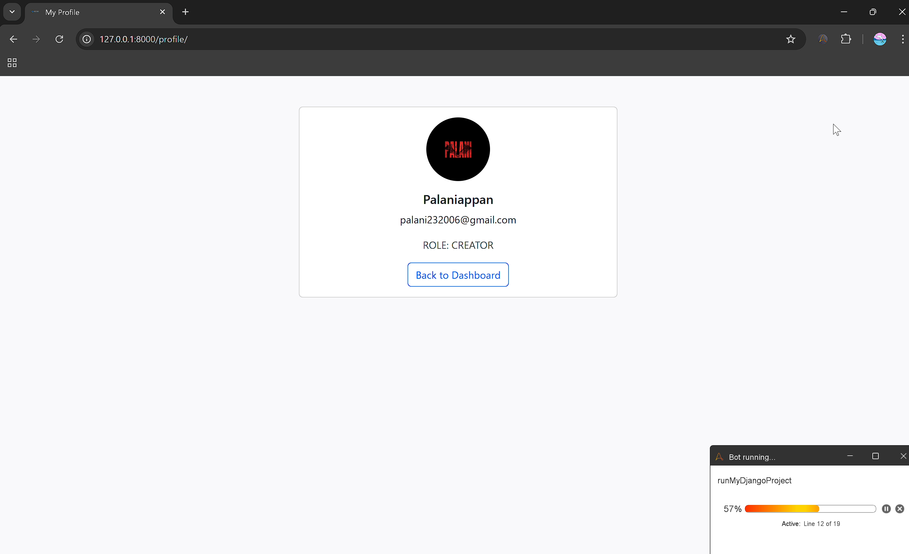

1. To view Profile a delay of 3 seconds is added, then Click Back to Dashboard.

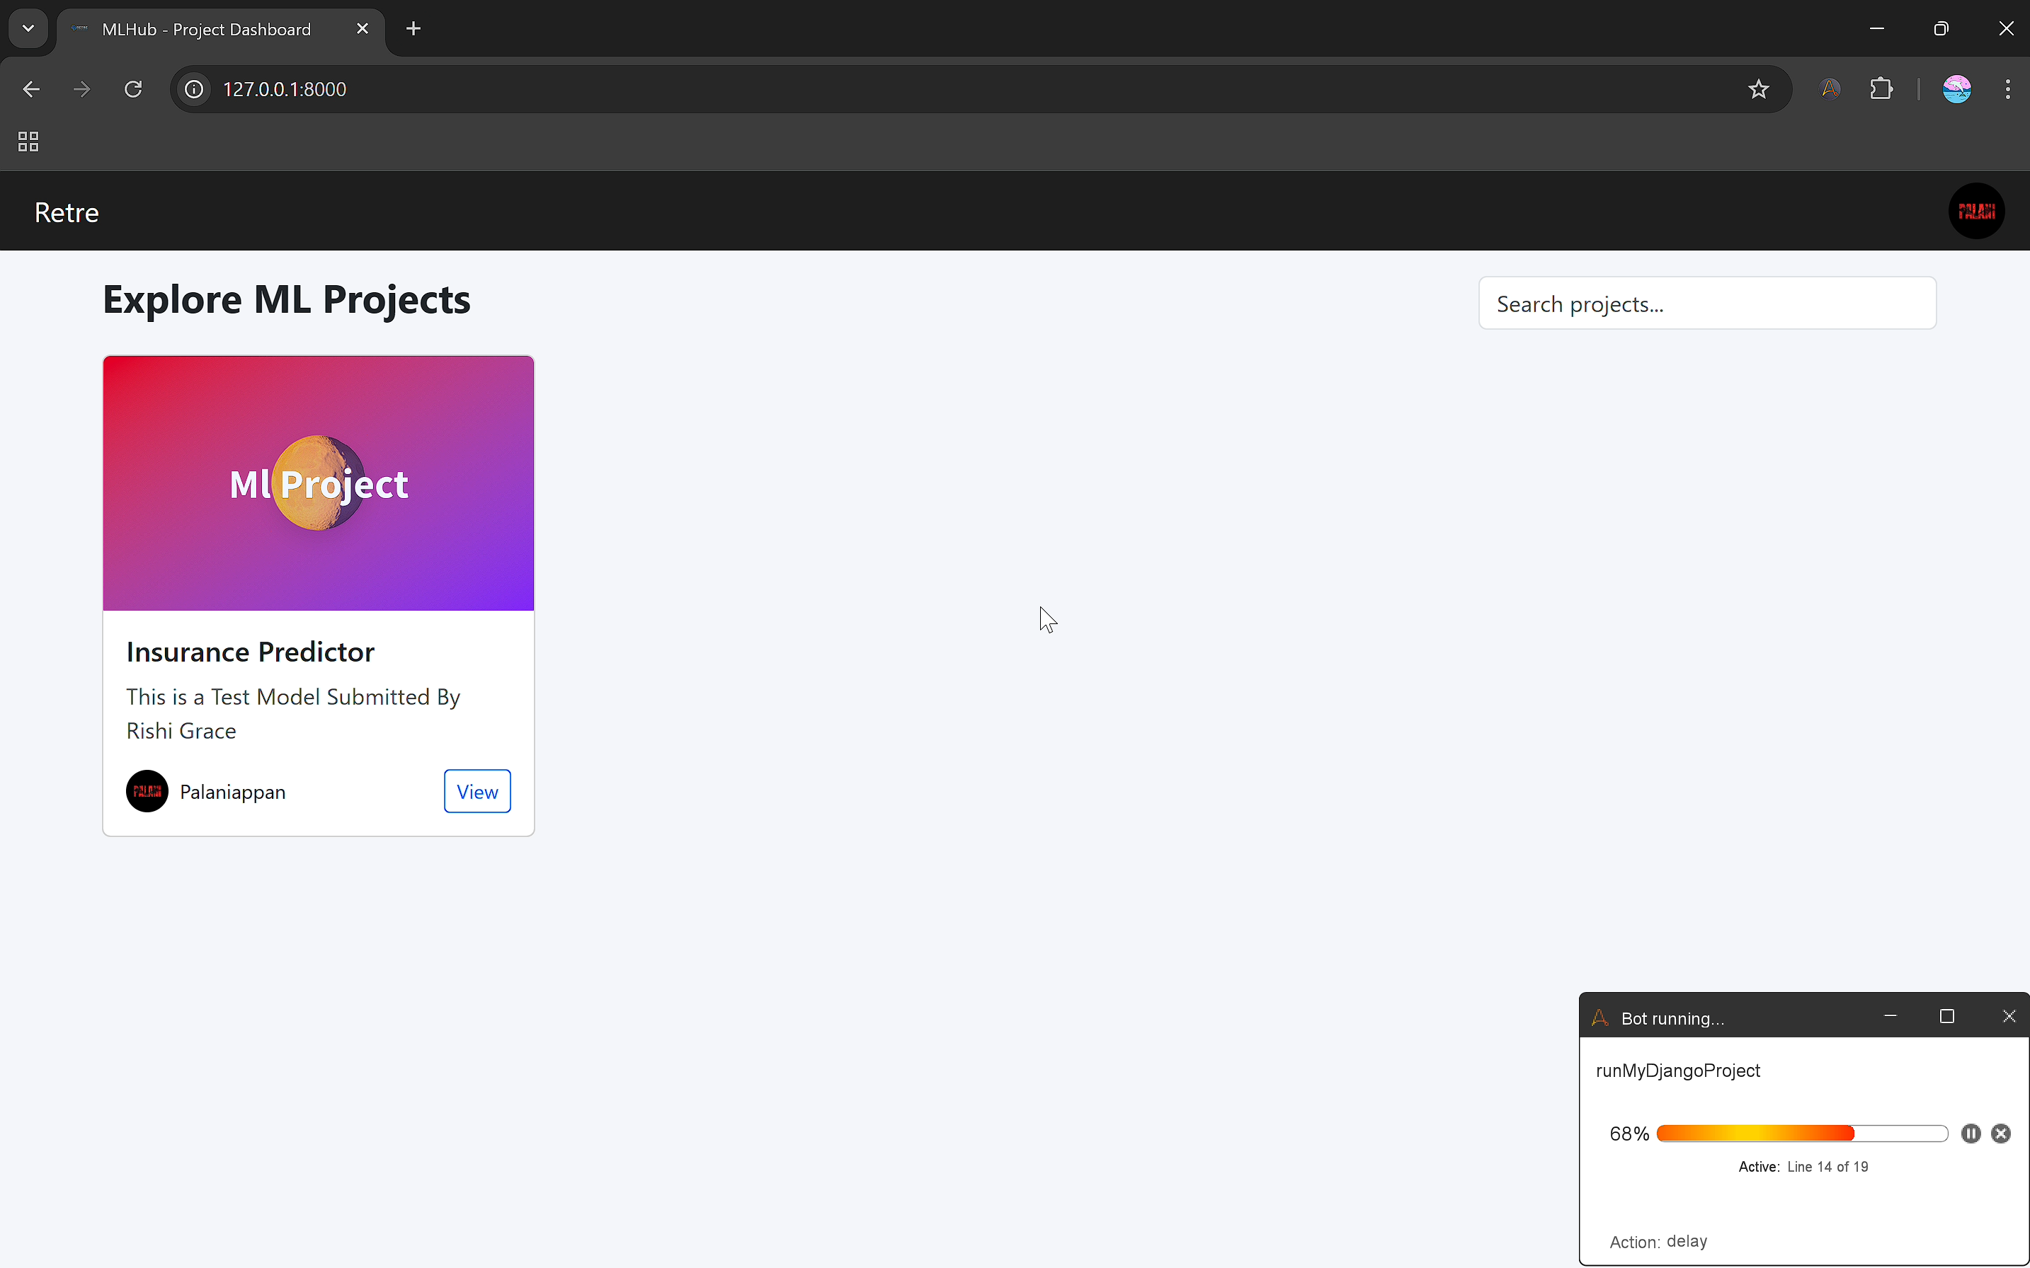

1. You will be re-directed to Main dashboard.

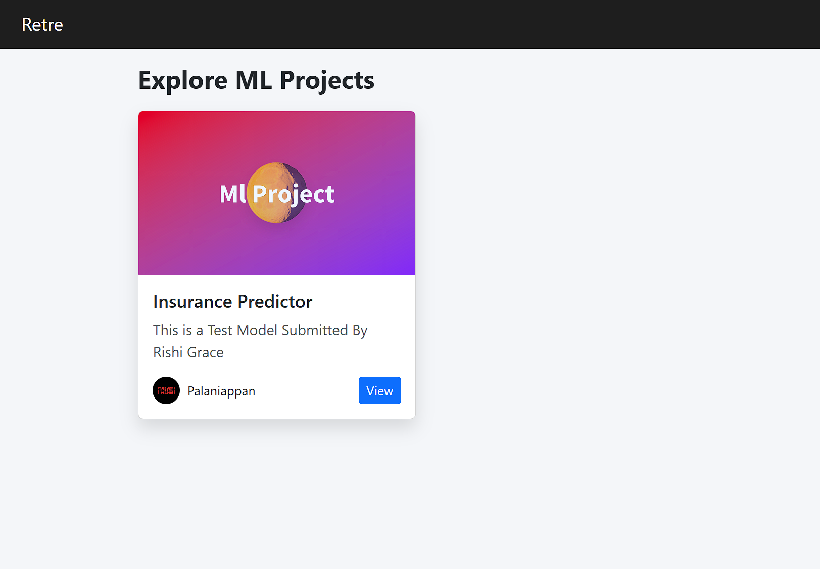

1. Click View in the Insurance Predictor

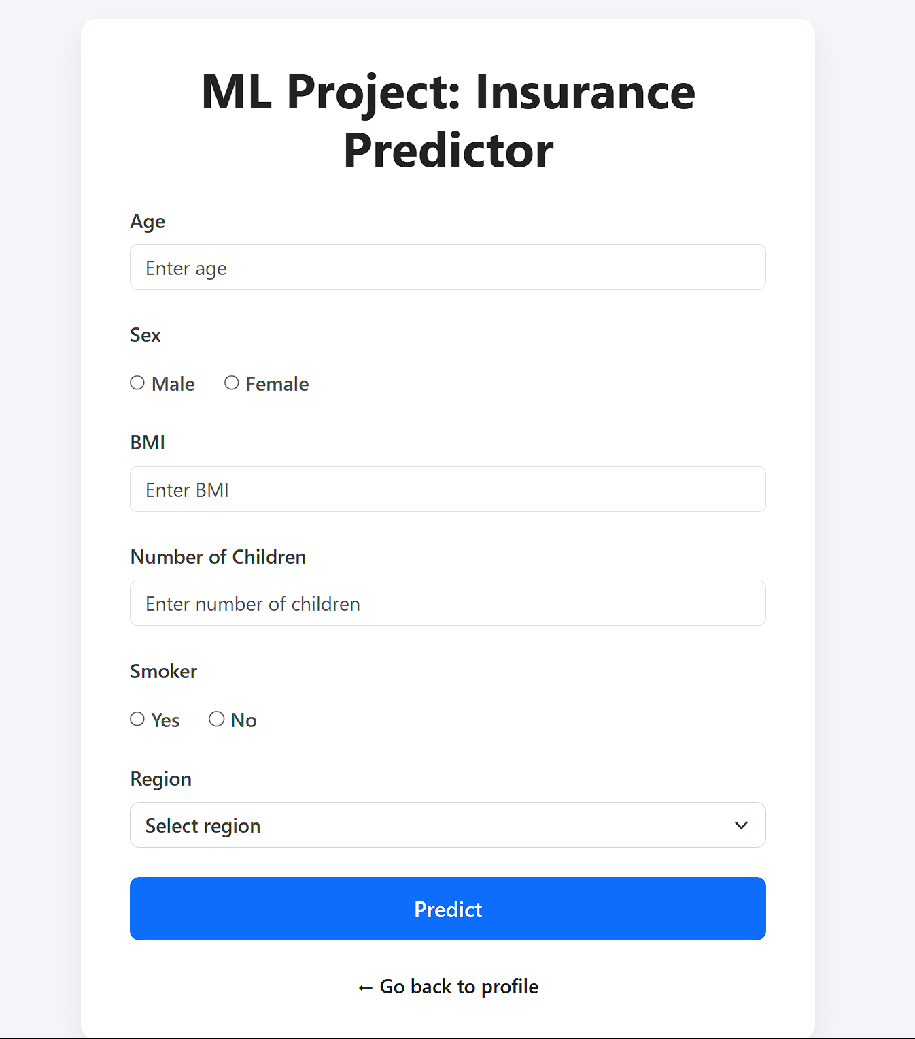

1. Go to ML Model Interface.

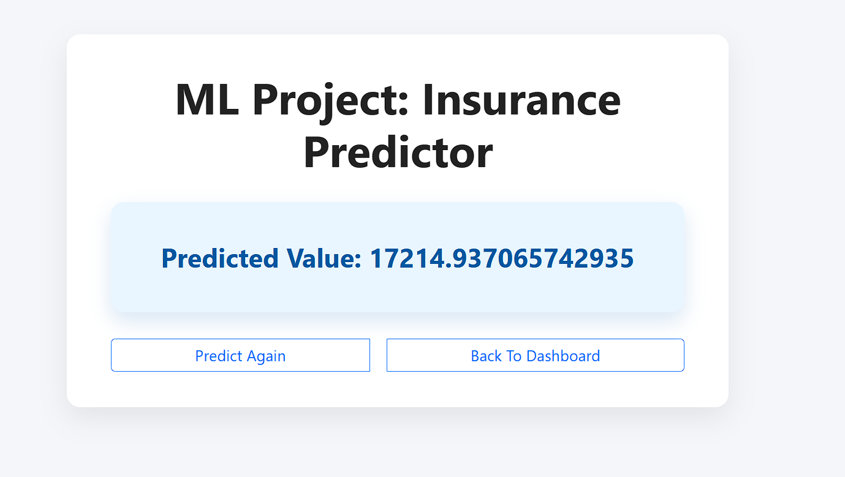

1. Inputs are served and output is extracted from result and stored to excel sheet.

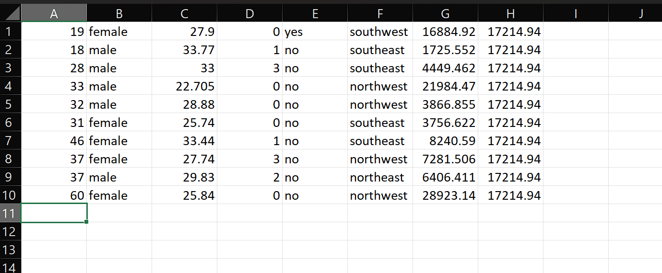

1. Once we get all the required values, save the excel file and, close both csv and excel file.

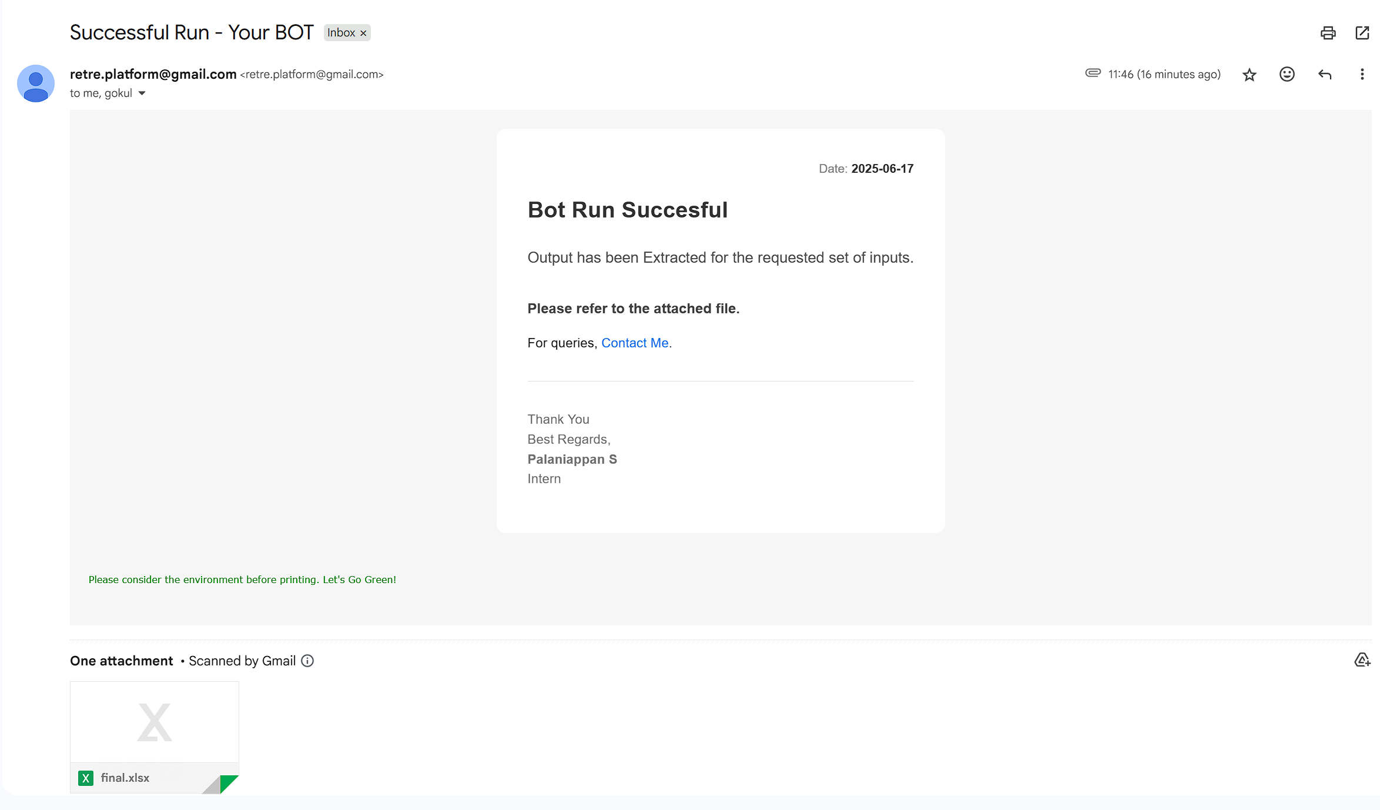

1. Mail is sent to the requested Mail ID(s) with the Extracted output in excel file.

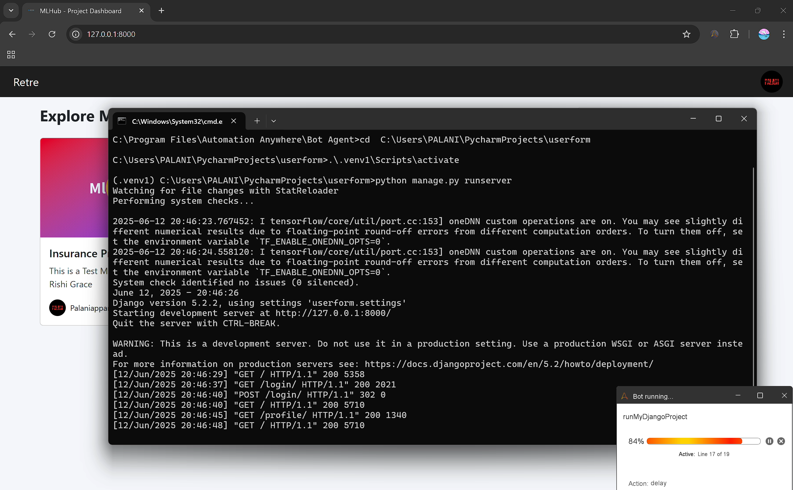

1. Open Command Prompt, enter CTRL+C to stop the Project and Close the Command Prompt.